Dear Parents

All Physical Education clothing is to be purchased from Land's End. Below is the description of the required pieces of clothing. The logos are required on all pieces (T-shirts, shorts, sweat pants and sweat shirts) of the gym clothing. When signing into Lands End.com, go to School Uniforms.
Please note: First grade will not be changing for gym and will not need a gym uniform, however they need to have separate sneakers to wear for gym purposes only and to be kept at the school.
Grades PK, JK, and K also are not required to have a gym uniform. Appropriate athletic footwear required for the early childhood grades
*************************************************************************************************
Lower School: 2nd to 4th grade
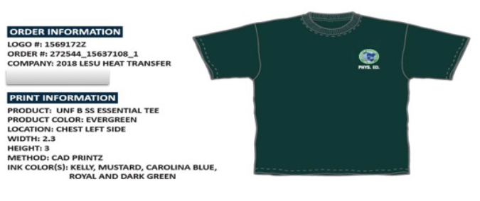
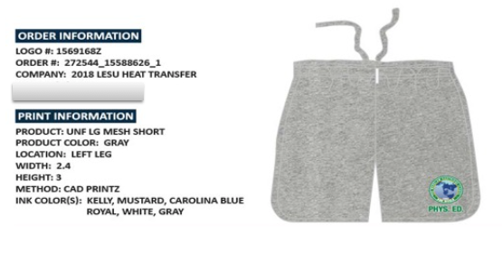

Middle School &Upper School: 5th-12th grade

